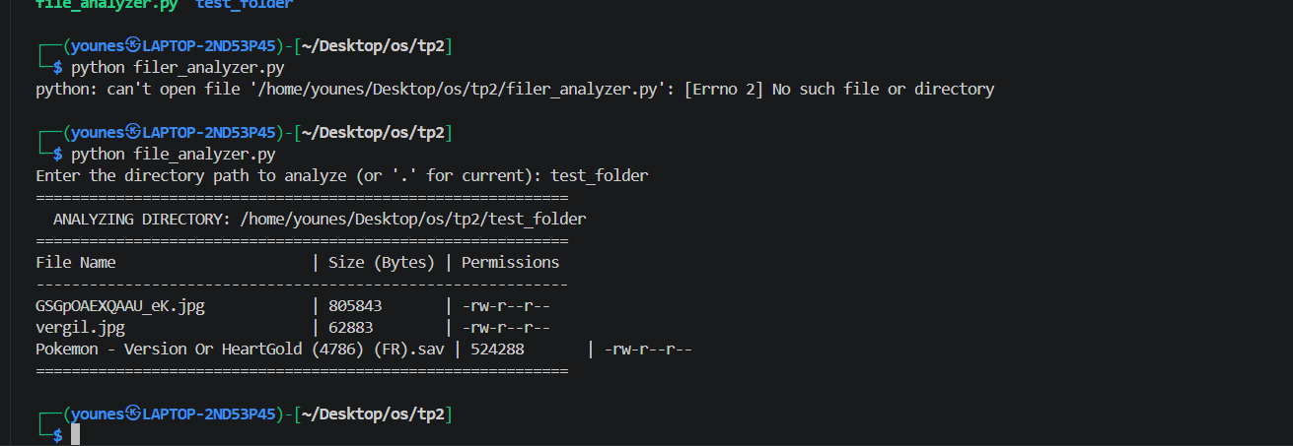
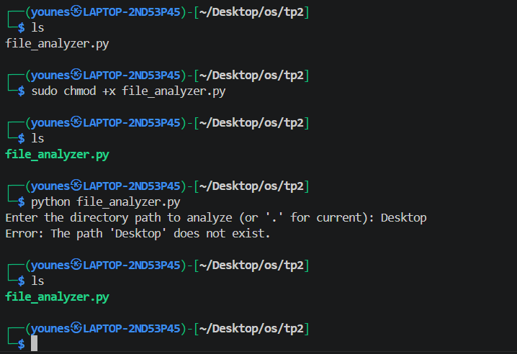
Final execution
We almost do for the test a test folder and do the chmod +x to had all of right and give the code executable for the all of work

